62

Professional Development Session on Youth Development
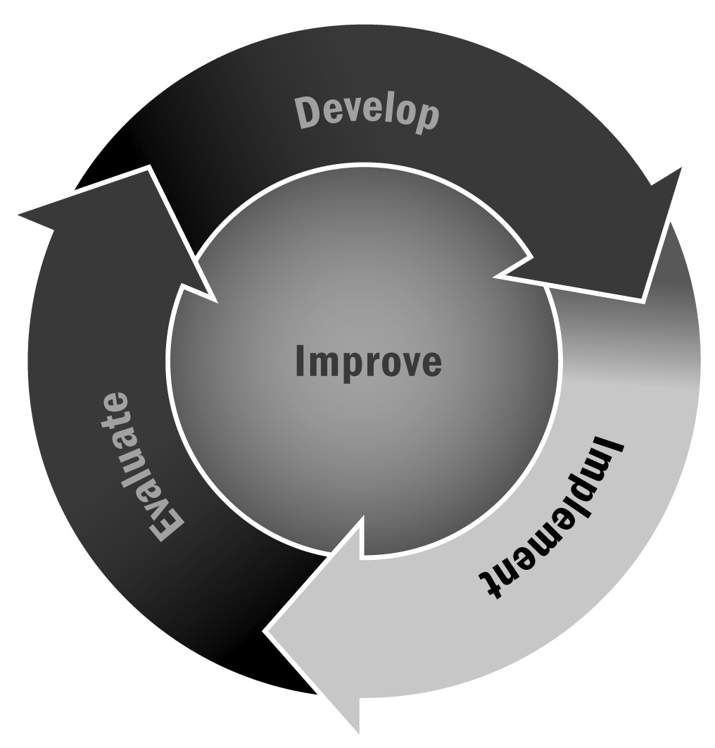
In Chapters 2 and 4, you learned that strong youth development principles are essential to a high-quality program. Incorporating youth development principles in the program practices can create positive academic and life trajectories for young people.
Directions: Use the following guidelines and worksheet to conduct a professional development session for staff members about integrating youth development principles into your program. All staff members should be encouraged to join in the discussion. This process will take anywhere from 70 to 90 minutes, depending on the number of team-building activities, the amount of discussion generated, and the number of activities addressed.

Objectives
- To understand the features necessary to create a youth development program
- To collectively establish how your program incorporates those features
- To determine how well a selected activity fulfills the criteria for youth development
- To develop a culture of continuous program improvement

Suggested Format
5 minutes | Facilitator describes the process for the meeting and explains the anticipated benefits and the importance of youth development.
5 minutes | Staff members read the section titled “Integrating Youth Development Practices Into Activities.” This section appears on pages 105–125 in this Toolkit.
10 minutes | The group discusses which of the afterschool and expanded learning program’s current or future activities and settings foster youth development. Then the group decides on one activity to focus on for further discussion.
10 minutes | Using the following worksheet, each staff member writes a brief description of the activity from his or her perspective and how the activity promotes or integrates youth development principles.
5 minutes | The group discusses how the goals of this activity align with youth development principles.
10 minutes | Individually, staff members complete Tool 63: Youth Development Checklist to see which features of youth development are being met throughout the entire afterschool and expanded learning program and which ones are not.
15 minutes | The group discusses the checklist results, revealing which aspects of youth development are being met and which are being neglected. An easel pad or whiteboard can be used so everyone can see the results. Then, the group discusses how activities can be adapted to achieve youth development.
5 minutes | The group determines the actions to be taken based on this discussion and who will be responsible for implementing any recommended changes to the activity.
5 minutes | The group discusses what has been learned by examining an activity in this manner.
Activity: Write a brief description of a current or future afterschool activity that incorporates one or more youth development principles.
Brief description of the activity:
In the following section:
- Write about how your activity purposefully integrates the following youth development practices. If it doesn’t align with all of them, that is okay.
- After you do that, get together with your group and discuss how you can improve your activity by either being more intentional about integrating youth development principles or by adding more youth development practices. Write down your new ideas in a different color if you have one.
Creating a Warm and Welcoming Environment – pages 106–108 in this Toolkit

Building Supportive Relationships and Opportunities to Belong – pages 109–113 in this Toolkit

Promoting Positive Behavior Management – pages 114–117 in this Toolkit

Offering Youth Choice – pages 117–118 in this Toolkit

Opportunities for Authentic Decision-Making – page 118 in this Toolkit

Youth Leadership – pages 118–119 in this Toolkit

Time for Reflection – pages 119–120 in this Toolkit

Skill Building: Sequenced – page 121 in this Toolkit

Skill Building: Active – pages 121–122 in this Toolkit

Skill Building: Focused and Explicit – page 122 in this Toolkit
Great job! Remember these practices every time you plan a set of activities, and remember, they are somewhat sequential, meaning that a warm and welcoming environment comes first, before you can expect youth to feel comfortable engaging in leadership activities, for example.

